MGMS – Project Tracking

Detailed Design Document

Ver. 1.4

Version History
Date | Description
15-Nov-2010 | First Draft

Table of Contents

Version History 2
1 Introduction 4
2 Project Tracking/Closure 4
3 Associated Tables 6
4 Data Dictionary 6

Introduction

This document provides the detailed design specifications for the Multisite Grant Management System project.

This is not a project plan nor does it detail the source code. It is a guide for system architecture and development, not for phasing, timelines or deliverables.

Finally, this is a ‘living document’ and the specification will change, continuously, as the project proceeds. More details will be added and the existing information edited as the requirements, architecture and design evolve in the course of the project.

Project Tracking/Closure

At different points in a project lifecycle, the user may record the important milestones or status also indicating the percentage of completion of project as on that date.
The track record may also be edited.

Screen & Control Description

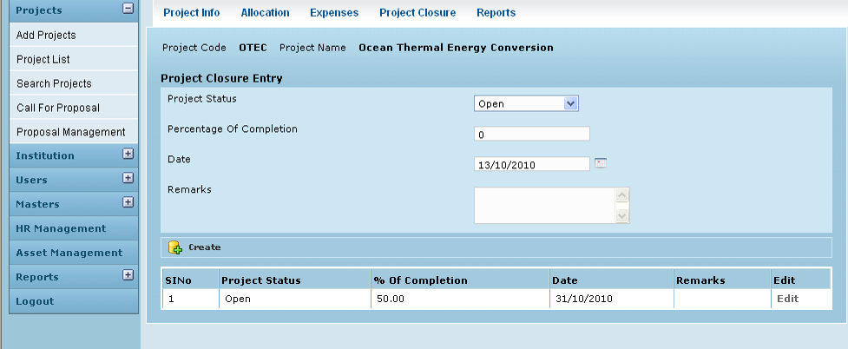

Field /Label | Input-Control | Data Type | Remarks/db table>field
Project Code: | Auto populated | varchar(255) | projects>code
Project Name | Auto populated | varchar(255) | projects>name
Project Closure Entry
Project Status | Listbox | varchar(255) | project_tracking>project_status
Percentage of Completion | Textbox | double | project_tracking>perc_of_completion
Date | Clendar | datetime | project_tracking>date_of_tracking
Remarks | Textarea | varchar(255) | project_tracking>remarks
Create | Button
Sl No | Auto increment  populated
Project Status | Auto populated | varchar(255) | project_tracking>project_status
Percentage of Completion | Auto populated | double | project_tracking>perc_of_completion
Date | Auto populated | datetime | project_tracking>date_of_tracking
Remarks | Auto populated | varchar(255) | project_tracking>remarks
Edit | Button

Edit

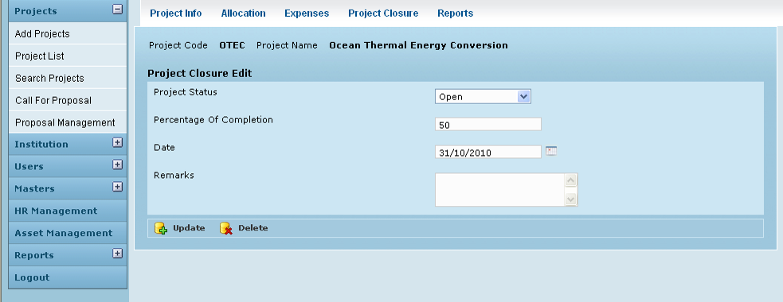

Field /Label | Input-Control | Data Type | Remarks/db table>field
Project Code: | Auto populated | varchar(255) | projects>code
Project Name | Auto populated | varchar(255) | projects>name
Project Closure Edit
Project Status | Auto populated & editable | varchar(255) | project_tracking>project_status
Percentage of Completion | Auto populated & editable | double | project_tracking>perc_of_completion
Date | Auto populated & editable | datetime | project_tracking>date_of_tracking
Update | Button |  | Message: “Status edited successfully”
Delete | Button |  | Changes deleted

Associated Tables

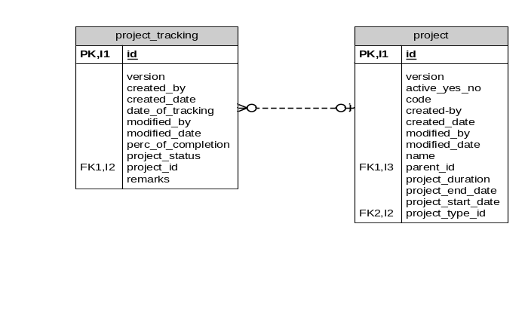

Data Dictionary

project_tracking

Fields

Field | Type | Collation | Null | Key | Default | Extra | Privileges
id | bigint(20) | (NULL) | NO | PRI | (NULL) | auto_increment | select,insert,update,references
version | bigint(20) | (NULL) | NO |  |  |  | select,insert,update,references
created_by | varchar(255) | latin1_swedish_ci | NO |  |  |  | select,insert,update,references
created_date | datetime | (NULL) | NO |  |  |  | select,insert,update,references
date_of_tracking | datetime | (NULL) | NO |  |  |  | select,insert,update,references
modified_by | varchar(255) | latin1_swedish_ci | NO |  |  |  | select,insert,update,references
modified_date | datetime | (NULL) | NO |  |  |  | select,insert,update,references
perc_of_completion | double | (NULL) | NO |  |  |  | select,insert,update,references
project_status | varchar(255) | latin1_swedish_ci | NO |  |  |  | select,insert,update,references
projects_id | bigint(20) | (NULL) | NO | MUL |  |  | select,insert,update,references
remarks | varchar(255) | latin1_swedish_ci | YES |  | (NULL) |  | select,insert,update,references

Indexes

Table | Non  unique | Key  name | Seq  in  index | Column  name | Collation | Cardinality | Sub  part | Packed | Null | Index  type
project_tracking | 0 | PRIMARY | 1 | id | A | 14 | (NULL) | (NULL) |  | BTREE
project_tracking | 1 | FK4DF711D905C4B9A | 1 | projects_id | A | 14 | (NULL) | (NULL) |  | BTREE

Foreign Key Relationships

FK Id | Reference Table | Source Column | Target Column | Extra Info
FK4DF711D905C4B9A | projects | `projects_id` | `id`

projects

Fields

Field | Type | Collation | Null | Key | Default | Extra | Privileges
id | bigint(20) | (NULL) | NO | PRI | (NULL) | auto_increment | select,insert,update,references
version | bigint(20) | (NULL) | NO |  |  |  | select,insert,update,references
active_yes_no | char(1) | latin1_swedish_ci | NO |  |  |  | select,insert,update,references
code | varchar(255) | latin1_swedish_ci | NO |  |  |  | select,insert,update,references
created_by | varchar(255) | latin1_swedish_ci | NO |  |  |  | select,insert,update,references
created_date | datetime | (NULL) | NO |  |  |  | select,insert,update,references
modified_by | varchar(255) | latin1_swedish_ci | NO |  |  |  | select,insert,update,references
modified_date | datetime | (NULL) | NO |  |  |  | select,insert,update,references
name | varchar(255) | latin1_swedish_ci | NO |  |  |  | select,insert,update,references
parent_id | bigint(20) | (NULL) | YES | MUL | (NULL) |  | select,insert,update,references
project_duration | varchar(255) | latin1_swedish_ci | YES |  | (NULL) |  | select,insert,update,references
project_end_date | datetime | (NULL) | YES |  | (NULL) |  | select,insert,update,references
project_start_date | datetime | (NULL) | YES |  | (NULL) |  | select,insert,update,references
project_type_id | int(11) | (NULL) | NO | MUL |  |  | select,insert,update,references

Indexes

Table | Non  unique | Key  name | Seq  in  index | Column  name | Collation | Cardinality | Sub  part | Packed | Null | Index  type
projects | 0 | PRIMARY | 1 | id | A | 137 | (NULL) | (NULL) |  | BTREE
projects | 1 | FKC479187A69DF6AED | 1 | project_type_id | A | 8 | (NULL) | (NULL) |  | BTREE
projects | 1 | FKC479187A43BA2D6A | 1 | parent_id | A | 137 | (NULL) | (NULL) | YES | BTREE

Foreign Key Relationships

FK Id | Reference Table | Source Column | Target Column | Extra Info
FKC479187A43BA2D6A | projects | `parent_id` | `id` | ,
FKC479187A69DF6AED | project_type | `project_type_id` | `id`

